* In the Monitoring section you can setup different diagnostic tools for logging like Alerts, Metrics etc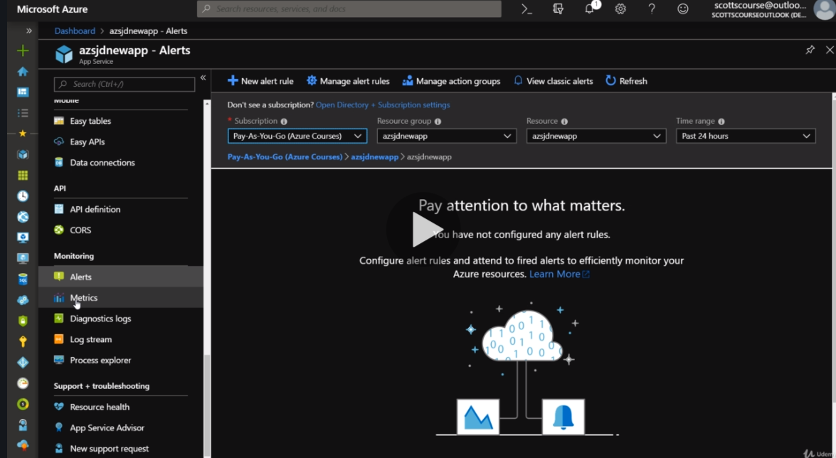
* Make charts in Metrics with 404 errors , usage, error codes and pin them to dashboard. 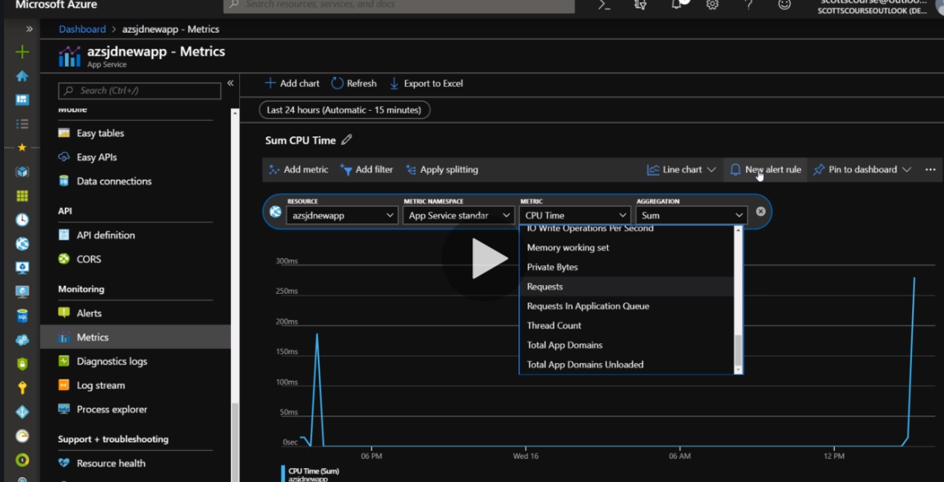
* You can also add Diagnostic logs to the app with a storage account to store those logs and a container to contain those logs. 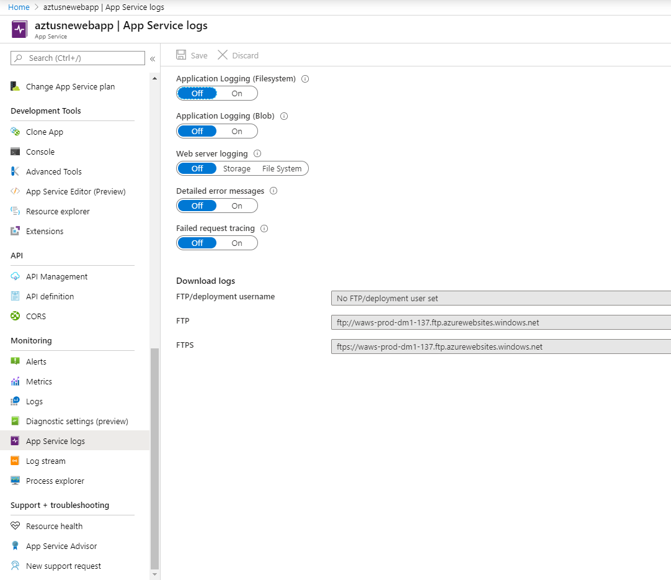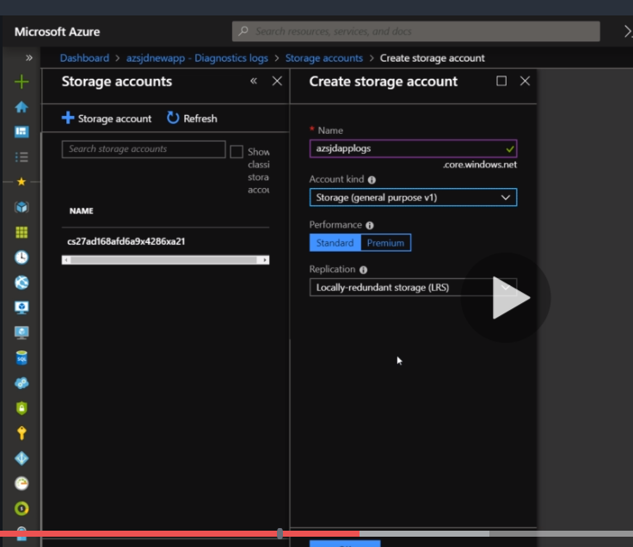
* Loginf here can be of two types. Application logging as well as Webserver logging
* After the logs are generated, they can be viewed in the storage account blob for a particular log there will be a folder. 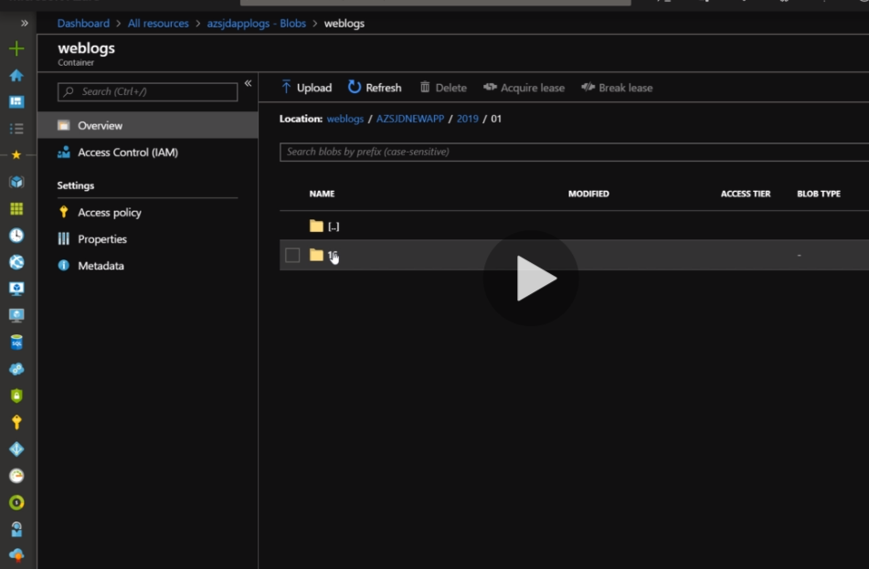
* Realtime viewing of the logs are done in Log Stream while testing for loadbalancing. Application logs are FileSystem logs